Water Pipeline Mentoring System Using None Destructive Method Via Vibration Sensor



Saad Bouabed (ME) , Khaled Alharthi (ME) , Khaled Alamri (CIE) , Abdullatif Bobshait (COE)



Introduction
Pipe leakage is one of the most common problems. The way of detecting small leakages is more complex than the large ones because the large size leakages can be noticed by our eyes or heard its noises by our ear.
Problem Statement
Develop a system that can detect leakages in a water pipeline through the Non Destructive Testing Method (NDT) using a vibration sensor and ensure detection with the aid of pressure sensors. Then creates alarming sounds and messages which reach the user through a smartphone application, to make him aware of the risk.

Prototype Design
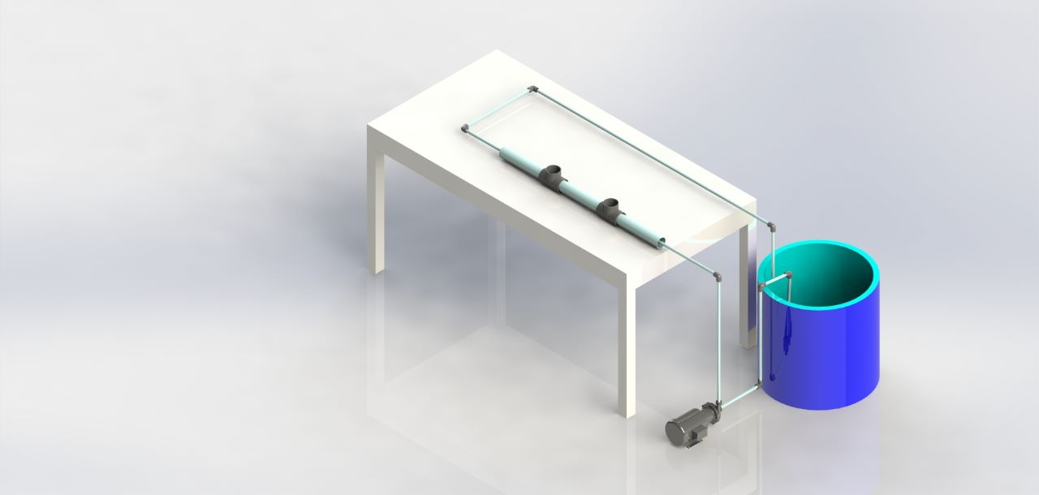
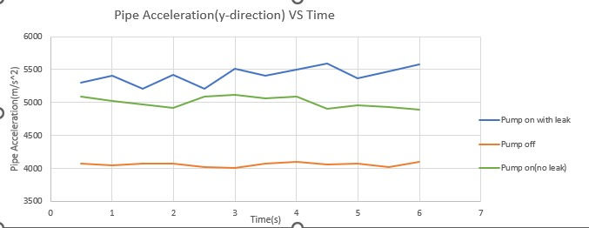

Components
MPU-6050 Accelerometer
Pressure sensor
Temperature sensor

Target specifications

•Pipe diameter: (4in)10cm ‡ 1cm.
• Single above the ground pipeline.
•The working fluid is water
•Uniform cross-sectional area.
•PVC is the pipeline material.
• Temperature: 273.15 - 363.15 kelvin
•Outer humidity: ≤50%
• Controller voltage: 5 V DC
• Leakage size 0.6mm #0.1mm

How ?

The method is to place a pressure sensor and a vibration sensor every 0.2 meters and measure the difference between the numbers in the case of leakage and between the numbers in the absence of leakage.

Testing

We have made many attempts to gather data to prove our theory.
Compared to the results, there is a big difference between the presence of leakage or not
The exact numbers of the leak
In the absence of leakage,
the range was between 5092 m/s^2 to 4904 m/s^2 and pressure between 5.77psi to 5.51 psi
in the presence of leakage,
the range was between 5591 m/s^2 to 5209 m/s^2 and pressure between 5.46psi to 5.41 psi

Conclusions

We proved that the method that can detect leakage is effective, can be tried and applied, and it is also inexpensive. And the use of vibration is a modern and effective method.
The use of data comparator is a modern method and is not used to detect leaks.
Finally we can develop it in the future

we learned

We learned that there are many ways to detect leaks, not all of them are effective, and most of them are expensive.
Finding an effective solution is a requirement for many partners.

improve it
We can accumulate the values for a certain period and then using artificial intelligence to predict the leakage
In terms of application.

A cordless development so that it
can be used in underground pipes.

It can be linked to an alarm or
notification of leakage via mobile
phone

