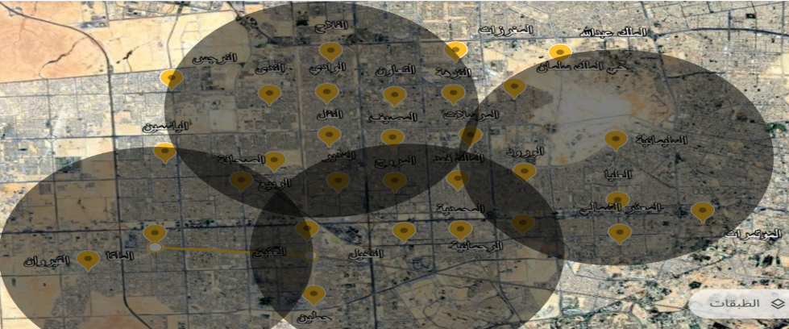

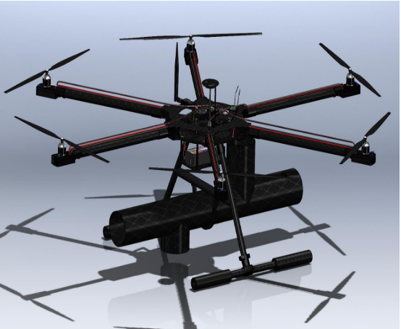
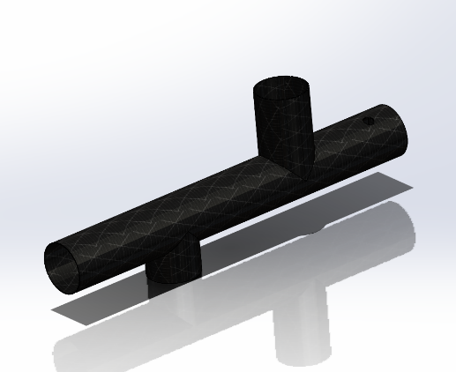
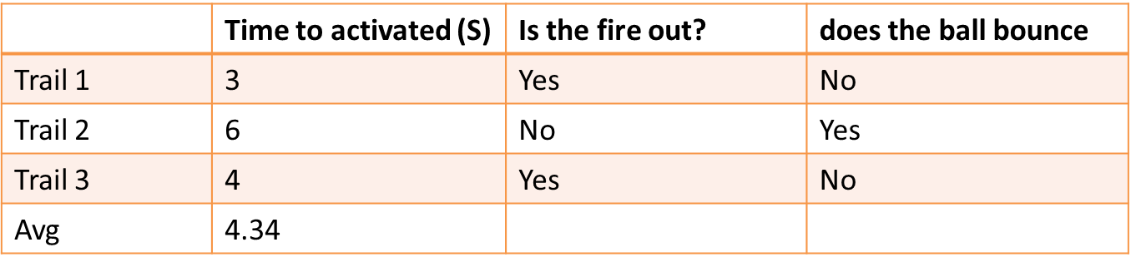

Prototype Design

- Battery Life: Minimum 20 minutes of continuous flight.
- Weight: Total weight, including payload, between 8–12 kg.
- Speed: Exceeds 40 km/h.
- Wind Resistance: Stable operation in winds up to 50 km/h.
- Altitude: Operates effectively at 75–100 meters.
- Temperature: Reliable performance up to 120°C.
- Launch Precision: Accuracy within ±0.5 meters.
- GPS Accuracy: Location error margin within ±2 meters.
- Range: Full operability up to 5 kilometers.
- Budget: Limited to SAR 7,000.
- Regulations: Must comply with GACA standards.
- Training: Operators require prior training.
- Safety: Maintain a minimum distance of 4× flame height.
- Specifications

Testing / Validation

Firefighting Drone

- Constraints

Constraints / Specifications
Presenting the Remote-Controlled Firefighting Drone capable of launching fire-suppressing balls. This innovative system targets fire-prone or hard-to-reach areas, enhancing firefighting efficiency and safety.
Design, construct, and test an advanced firefighting drone equipped with a ball-launching system to suppress fires in inaccessible areas, ensuring precision, safety, and efficiency. Additionally, establish strategically located drone stations to enable rapid response and enhanced fire management capabilities.

Fires in inaccessible areas pose significant challenges to traditional firefighting methods, often resulting in critical delays and increased safety risks. There is a pressing need for an innovative solution to enhance firefighting efficiency, precision, and safety in such scenarios.

- Project Scope

- Problem Statement

Introduction / Background

Elevator Pitch

TEAM: 53
Firefighting Drone

Abdullah Alshami CHE Abdulrahman Alakassi ISE
Sahal Ashmawi ISE Jawad Al Dakheel AE
Yazeed Alasmi EE

