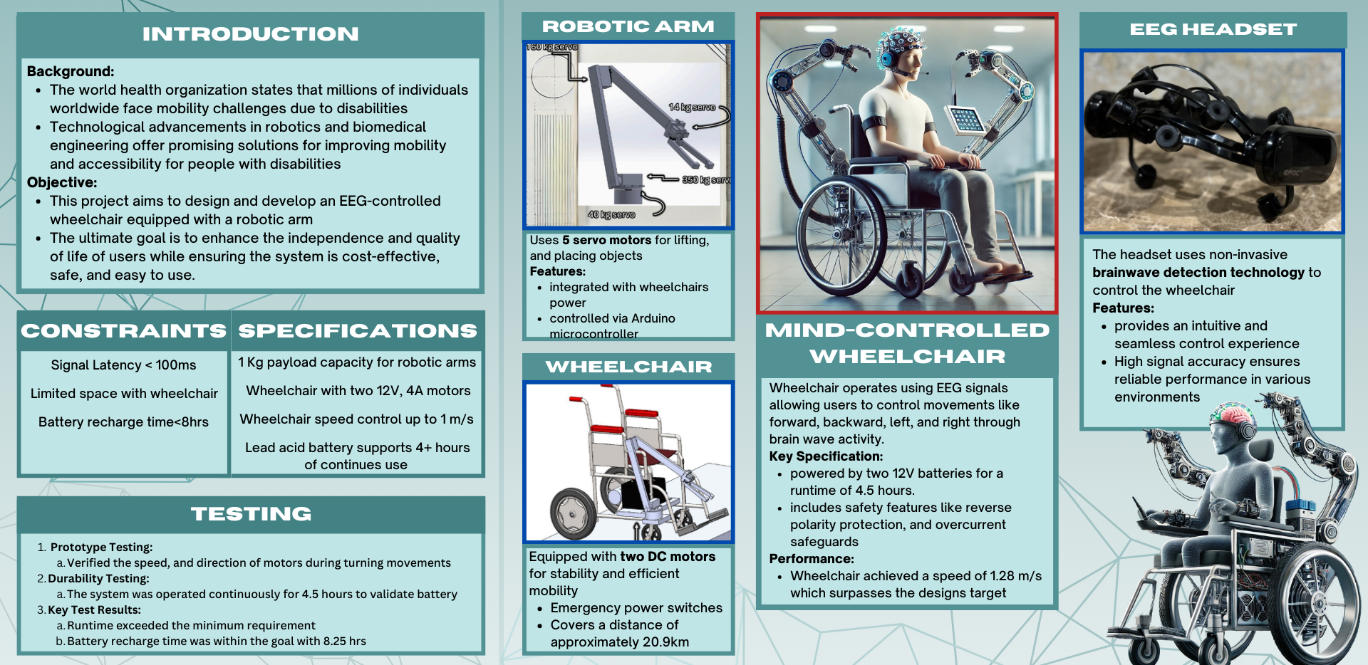

Abdullah Alroumaih CS Ibrahim Alotaibi COE Abdulelah Alkadhem ME Hassan AL-Shawaish EE
Mujtaba AL-Bahrani EE
Mind-Controlled Wheelchair Featuring Robotic Arm for Assistive Applications
TEAM: 05

