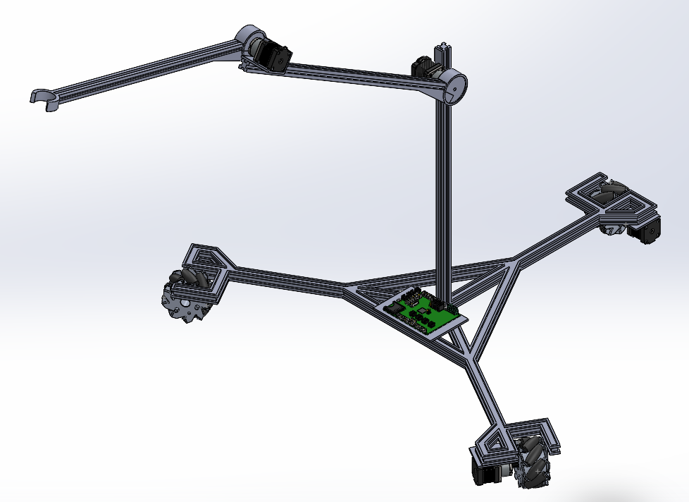
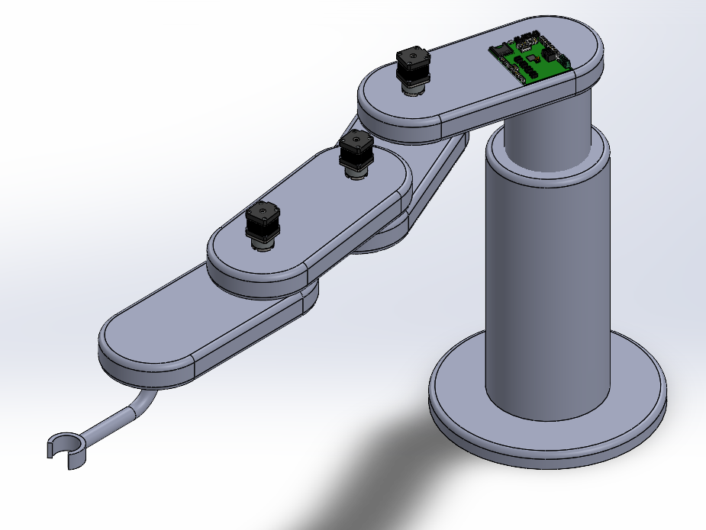
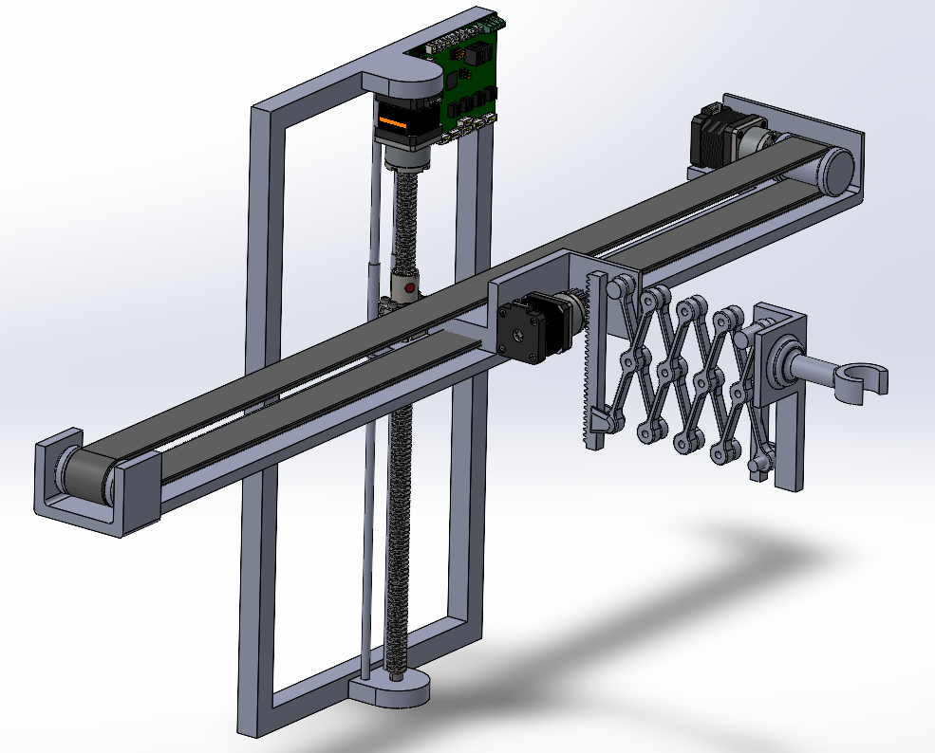
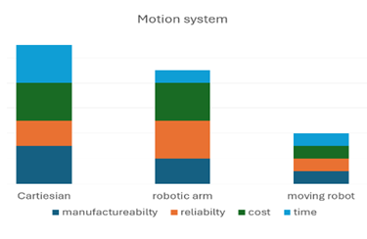

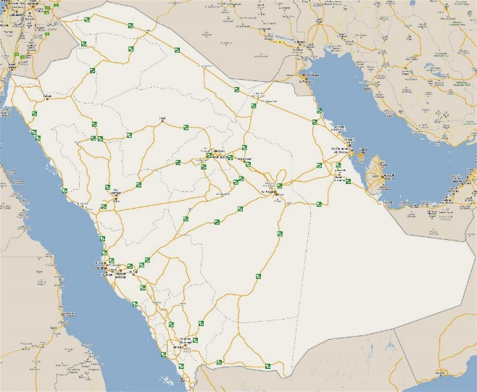
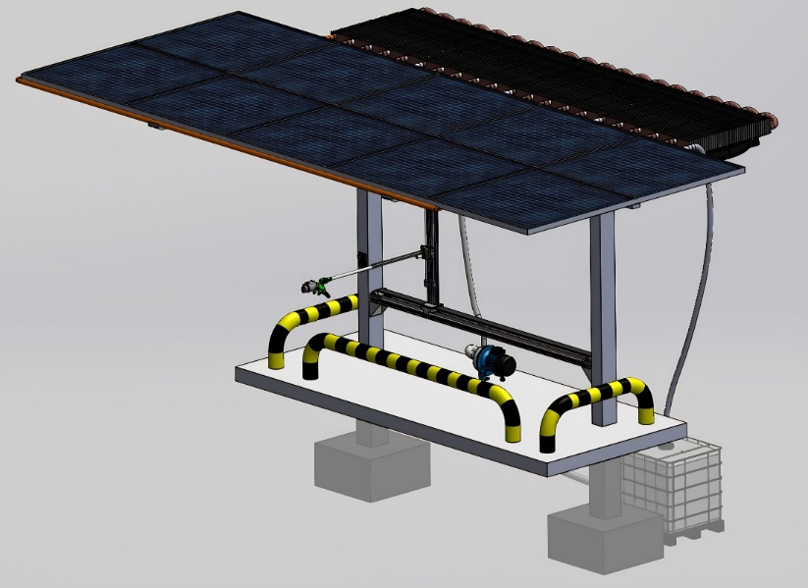
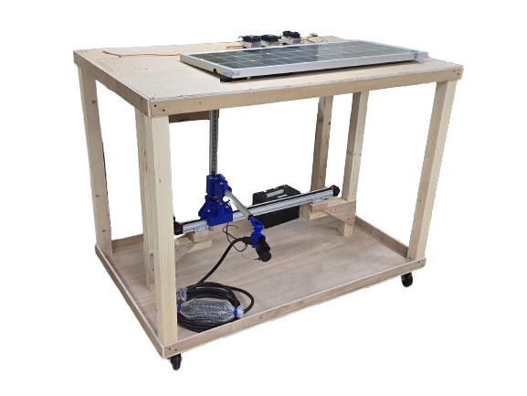

Future improvements:
- Developing a machine learning model for closed port detection that can be work most EV cars on the road
- Developing an app to show the available units and their occupancy

Testing
When an object is detected in a 2 meter radius for over 10 seconds, the scanning phase begins, lasting approximately 12 seconds.
The motion system then moves the charger to the exact position while measuring the remaining distance and forces on the charger
The system waits until charging starts to notify the user.

Conceptual Design

Constraints
minimum width of the Station 2 m
Roof area of 10 $m^{2}$
Fully collapsed length of less than 30cm

Important equations
$$T=\frac{Fl}{2πη}$$
$$\dot{m}tc_{w}ΔT_{ω}=m_{g}C_{g}ΔTg$$
$$Solar efficiency = \frac{Pgenerated - Ppump}{Pirradiance}$$

Prototype CAD

Background
Problem Statement: Saudi Arabia's 75,000-kilometer road network faces a critical challenge, with 20% of its roads deemed unsuitable for supporting electric vehicle (EV) infrastructure. This limitation hinders the 2030 vision progress toward widespread EV adoption and integration.

Hamzah alshaikh CHE Mohammad Al-Khalafah EE
Muhannad Alsaeed ME Mohammed Aldllbahi ME
Osama al-Johani CEE
Specifications
The robotic arm of 1 m
EV port detection radius of 2m
Average efficiency increase of 10% by cooling
Dynamic recalculation system of 15s or less

Autonomous EV green charger
TEAM: 38

