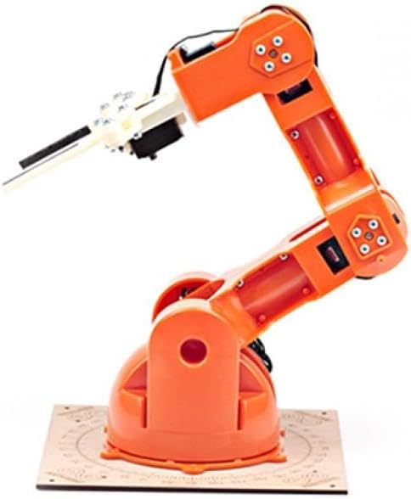

Optimizing UAV Performance through In-Flight Battery Exchange for Endurance and Operational Efficiency

Target Specifications
- Battery Swap Time: Less than 30 seconds to minimize operational downtime.
- Battery Capacity: Increase flight time by at least 50%.
- System Weight: Increase less than 5% of the drone’s total weight.
- Safety Compliance: Adheres to GACA and international aviation standards.
- Autonomy: Capable of autonomous in-flight battery swapping to maintain efficiency.

Prototype Design

Components:
- Utilizes an Arduino-controlled arm for swapping batteries, designed to be lightweight and efficient.

- 3D Printed Battery Models: Utilized 3D printing technology to create identical battery models that are consistent in weight and dimensions, tailored for the DJI M350 drone. This approach ensures precision and uniformity, essential for accurate testing and evaluation.

- Functionality: Demonstrated ability to perform battery swaps autonomously with minimal deviation (86-87 degrees on a required 90 degrees).

Constraints:
- Weight Constraint: Additional weight from the battery swap system must not significantly impact UAV's flight time and maneuverability.
- Safety and Regulations: Must comply with General Authority of Civil Aviation (GACA) standards to ensure safety and legality.

Introduction:
This project aims to significantly enhance the operational capabilities of Unmanned Aerial Vehicles (UAVs) by developing an innovative in-flight battery exchange system. The primary objective of this endeavor is to extend UAV endurance and improve operational efficiency by overcoming the current limitations posed by battery capacity. This breakthrough has the potential to expand the scope and effectiveness of UAV applications across surveillance, logistics, environmental monitoring.

Problem Statement:
UAVs are currently limited by battery capacity, which restricts their flight duration and range. This limitation affects their effectiveness in applications like surveillance, logistics, and emergency interventions.

Validation:

- Performance Metrics: Successful reduction in battery swap time to below 30 seconds, through an automated quick-release mechanism.
- Extended Flight Time: Achieved a 50% increase in flight duration.
- Prototype Testing: Initial tests show the system meets design parameters with a swap time of approx. 22.1 seconds.

Conclusion

The project successfully demonstrates a significant improvement in UAV operational efficiency by extending flight times and reducing downtime for battery swaps. With continued development and refinement, this system has the potential to revolutionize UAV applications across commercial, environmental, and humanitarian sectors.

Names and Depts

Name: Mohanad Amer Major: CHE

Name: Saud Alshammari Major: CHE

Name: Omer Alshammari Major: EE

Name: Waleed Alburayt Major: AE

Name: Ahmad Alghamdi Major: ISE

Name: Hamza Khamis Major: EE

