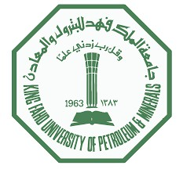
- Heat flow applied with convection on all exposed surfaces.
- Blue layers: Air convection region
- Green and yellowish colors: Effective heat absorption in PCM material
- Efficient heat transfer properties of the PCM layer demonstrated in the simulation.

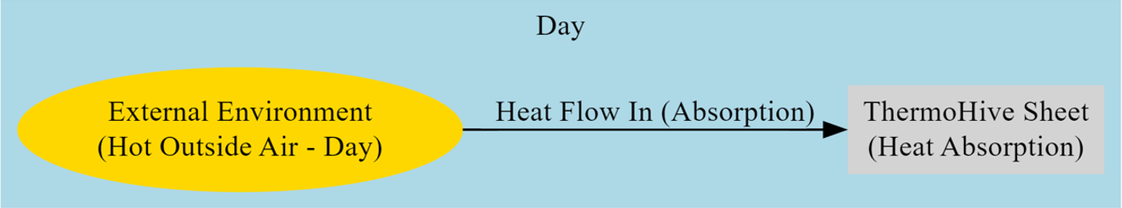
Block Diagram
25 cm
25 cm
Lower PP Layer
Honeycomb sheet layer filled with PCM
Upper PP Layer
EVA Layer
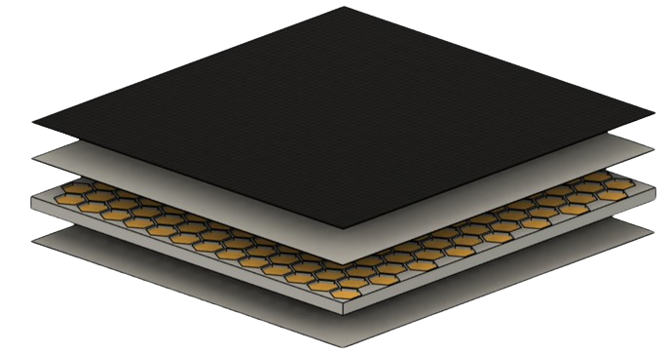
Prototype Design
Final product
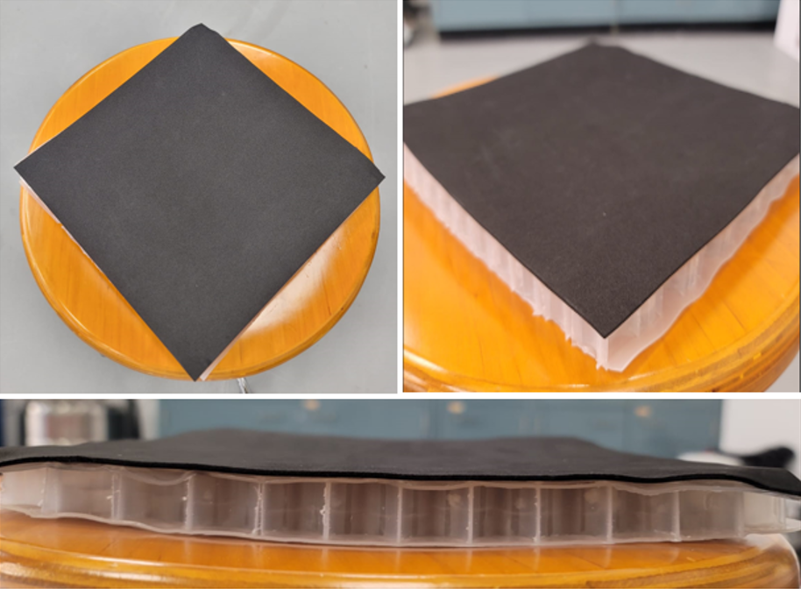
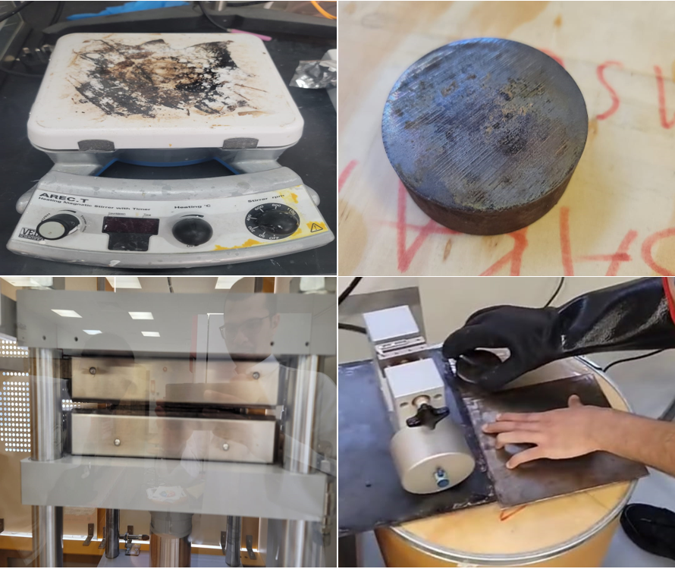

Fabrication and hot sealing
Assembling process step by step
54
4
2
1
3
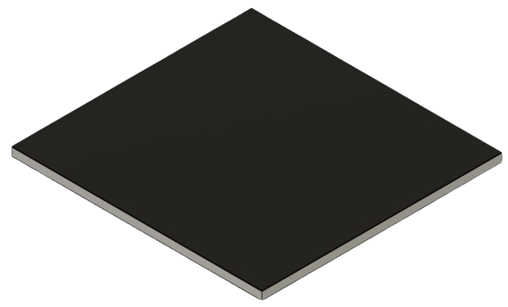

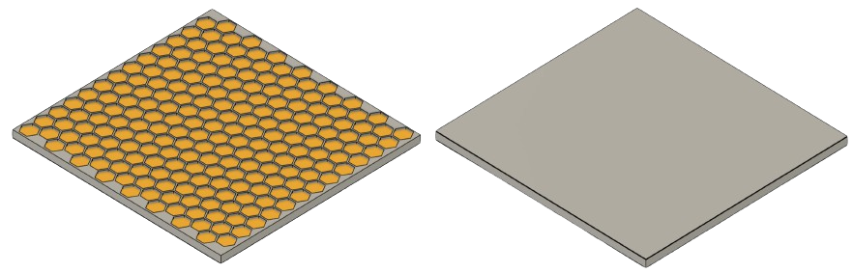
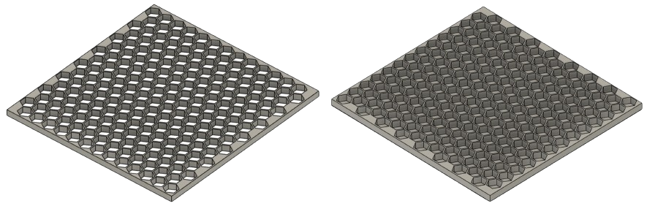
Assembling
Testing and results
GREEN CHEMISTRY IN BUILDING ENVELOPES: SUSTAINABLE U-VALUE REDUCTION THROUGH ECO-FRIENDLY MATERIALS AND PROCESSES
Team 62
MSE: Mohammed Abu Ruzaizah, Mohammed Alharbi - CHE: Suliman Mohammed, Abdulelah Sendi - ME: Mohammed Alali, Ayman Alghafli
Advisor: Dr. Fahad Alam

With the continuous activity of volcanoes, changes on the Earth's surface will continue. Scientists continue to study rock formations and layers and discover new information.
Specification
Min Operating Temperature 151$℃$
PCM Type Glycerides
Thermal Conductivity 0.2 W/m$℃$
Phase Change Temperature 25-30 $℃$
Latent Heat Capacity 202 J/g
Dimensions 25$×25×2$cm
In 2021, Saudi Arabia experienced a significant 4.23% rise in electrical energy consumption, reaching 301,600 gigawatt-hours (figure 1). If we go deeper, we can notice that the electricity consumption will significantly raise in other seasons compared with winter and one of the reasons of that is the increased in air conditioning use during peak heat periods (figure 2). In response, the government is focusing on boosting energy efficiency, particularly through enhanced insulation techniques. The insulation market in Saudi Arabia is projected to more than double, growing from USD 100 million to USD 230 million by 2030 (figure 3). This expansion is driven by extensive construction projects and regulatory reforms designed to elevate insulation adoption from 4% to 20%, underscoring the country's commitment to sustainable energy management. Our project aims to enhance building energy efficiency using PCM Glycerides (esters from glycerol and fatty acids) for insulation in hot, desert regions where temperatures range from 30 to 40 degrees Celsius. The project is expected to significantly enhance energy efficiency, reduce carbon emissions, improve indoor comfort, and promote sustainable building practices in hot, desert regions, while ensuring durability and market compliance.
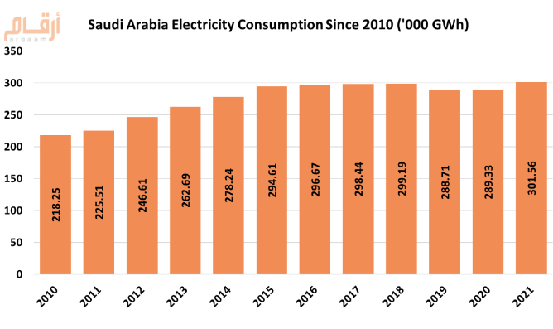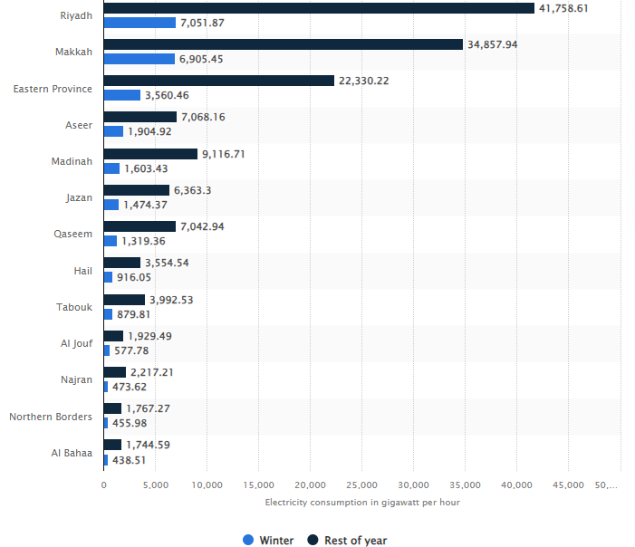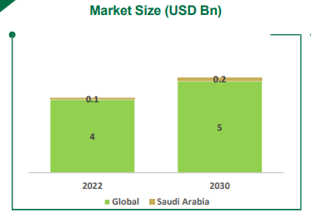

Introduction

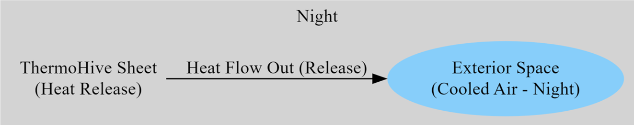

Simulation

References
Heat Sink simulation of phase change material (PCM)
- 7mm Air &13mm PCM
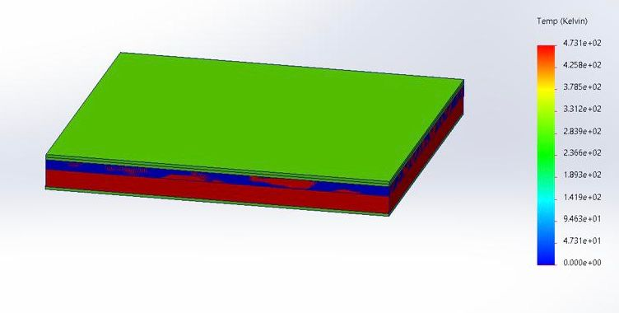
- 10mm Air &10mm PCM
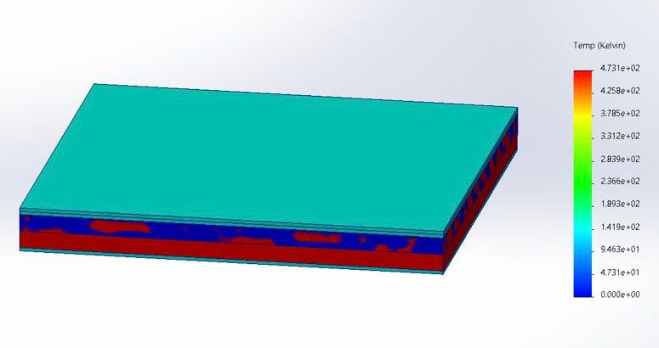

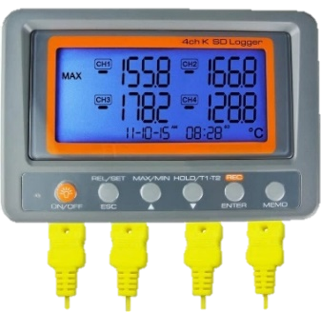
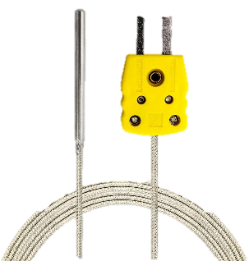
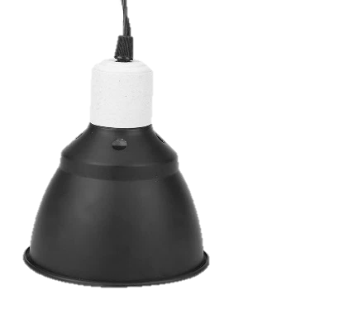
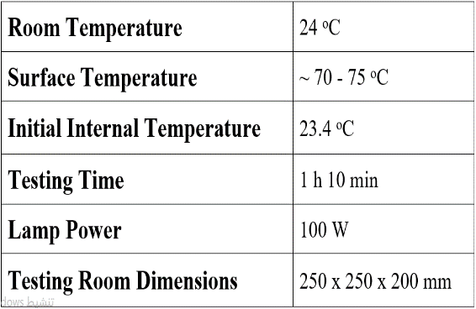
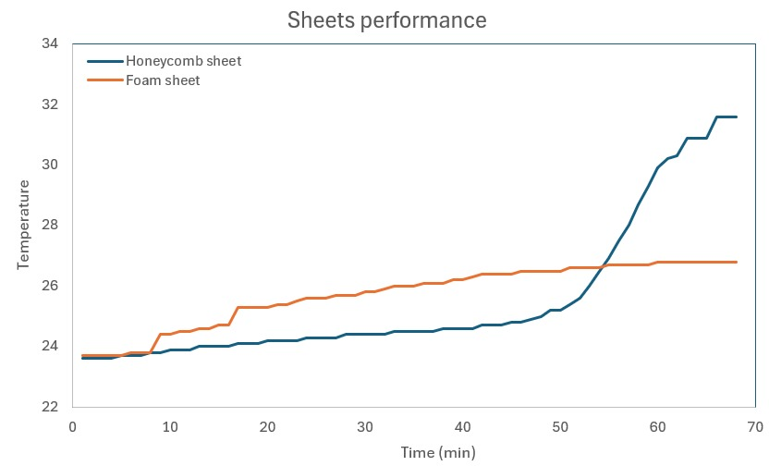
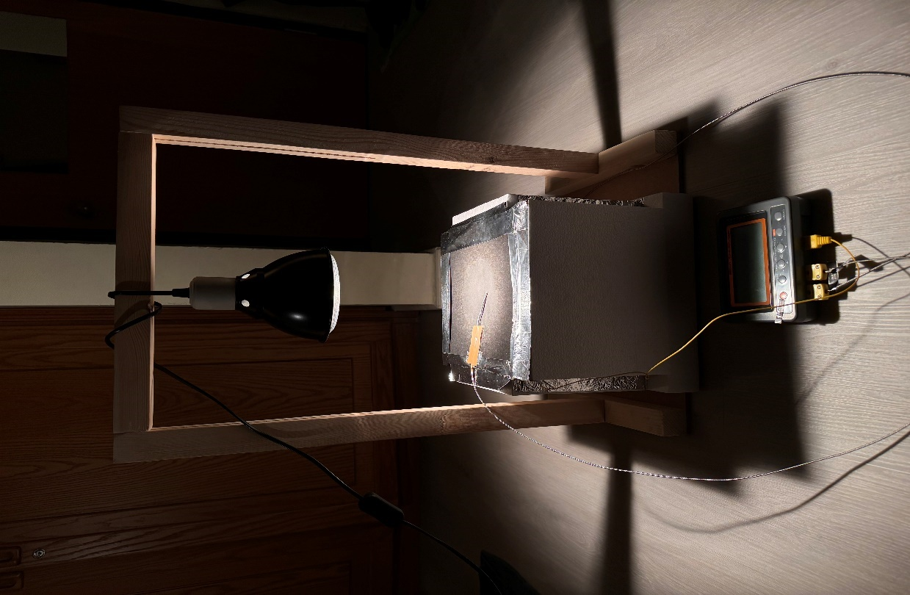
constrains
Complying with building codes
Time
Temperatures ranging between 30 to 40 $℃$
Reducing peak temperatures by at least 3$℃$
Market Availability
PCM Compatibility
- Polymer layers are depicted in slightly blue color.
- The blue color suggests lower heat transfer compared to the previous simulation.
- The thickness of the air layer affects heat flow dynamics.
- Varying layer thicknesses impact heat transfer efficiency in the honeycomb structure.

Instruments Used in the Experiment: (a) Halogen lamp, (b) K type thermocouples, (c) Data logger.
(a)
(b)
(c)
Standard Parameters.
- A set of simple material, as illustrated in the above image, was used to simulate real buildings and to test all alternatives.
- As showed in the performance sheet, our prototype exhibited positive results in its heat insulation in the first 50 minutes of the test compared to polystyrene, which is commonly used in the local market.
the Performance of our Prototype & Polystyrene.
In conclusion, the innovative ThermoHive insulation material showed promising results compared to Polystyrene, especially when it used in temperatures ranging from 24 to 48 degrees Celsius. Under these conditions, our prototype was able to maintain low internal temperatures, around 23 degrees Celsius, in the test chamber. However, a decline in the performance of the insulation material was observed after 55 minutes from the start of the test. This decrease in performance is attributed to the possibility that the phase change material had completely melted due to the temperature rising to high levels, leading to a loss of its insulating properties and a reduction in its effectiveness.

Testing Chamber.
Conclusion

